Title: Payment Transaction Management System
Project Title: E-Commerce Order Management System

Project : E-Commerce Order Management System
Student Name : Sarulatha P
Register Number : C4S38004
Department : III - AI
Course : Artificial intelligence (AI)
Academic Year : 2026 – 2027

1. Create Database
CREATE DATABASE payment_db;
USE payment_db;
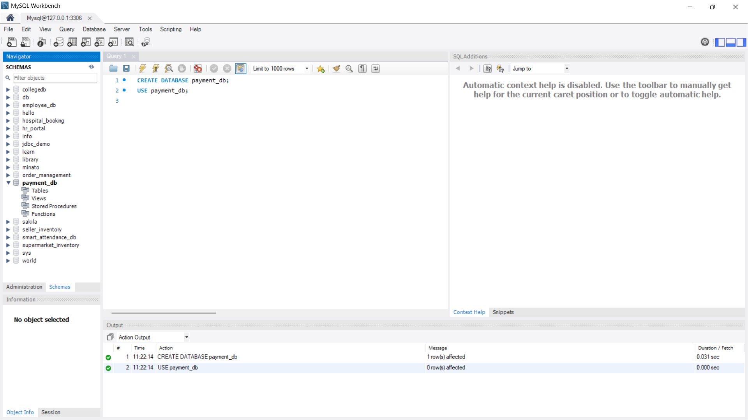

2. Create Payment Table
CREATE TABLE Payment (
payment_id INT PRIMARY KEY AUTO_INCREMENT,
order_id INT,
amount DECIMAL(10,2),
payment_mode VARCHAR(20),
payment_date DATE,
status VARCHAR(20)
);
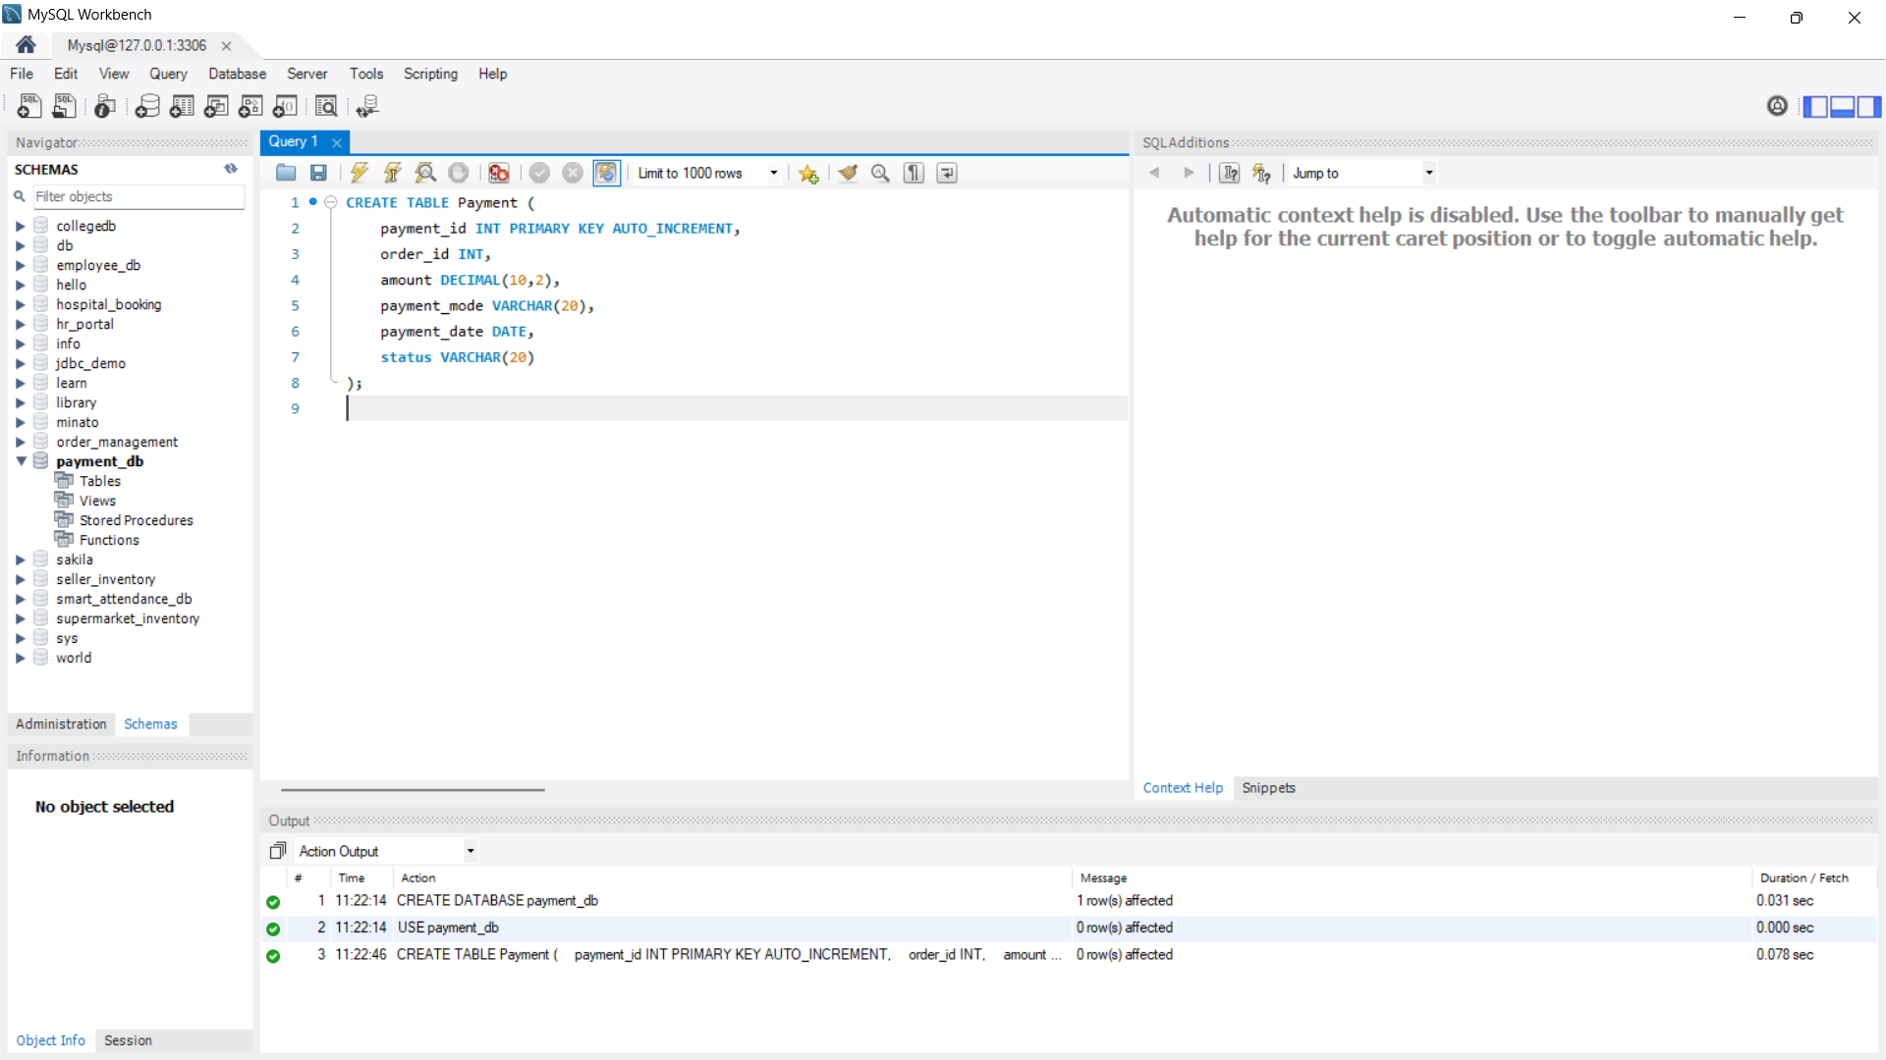

3. Insert Data
INSERT INTO Payment
(order_id, amount, payment_mode, payment_date, status)
VALUES
(101, 1500, 'UPI', '2026-08-01', 'Success'),
(102, 2500, 'Card', '2026-08-02', 'Success'),
(103, 800, 'UPI', '2026-08-03', 'Failed'),
(104, 1200, 'Cash', '2026-08-04', 'Success');
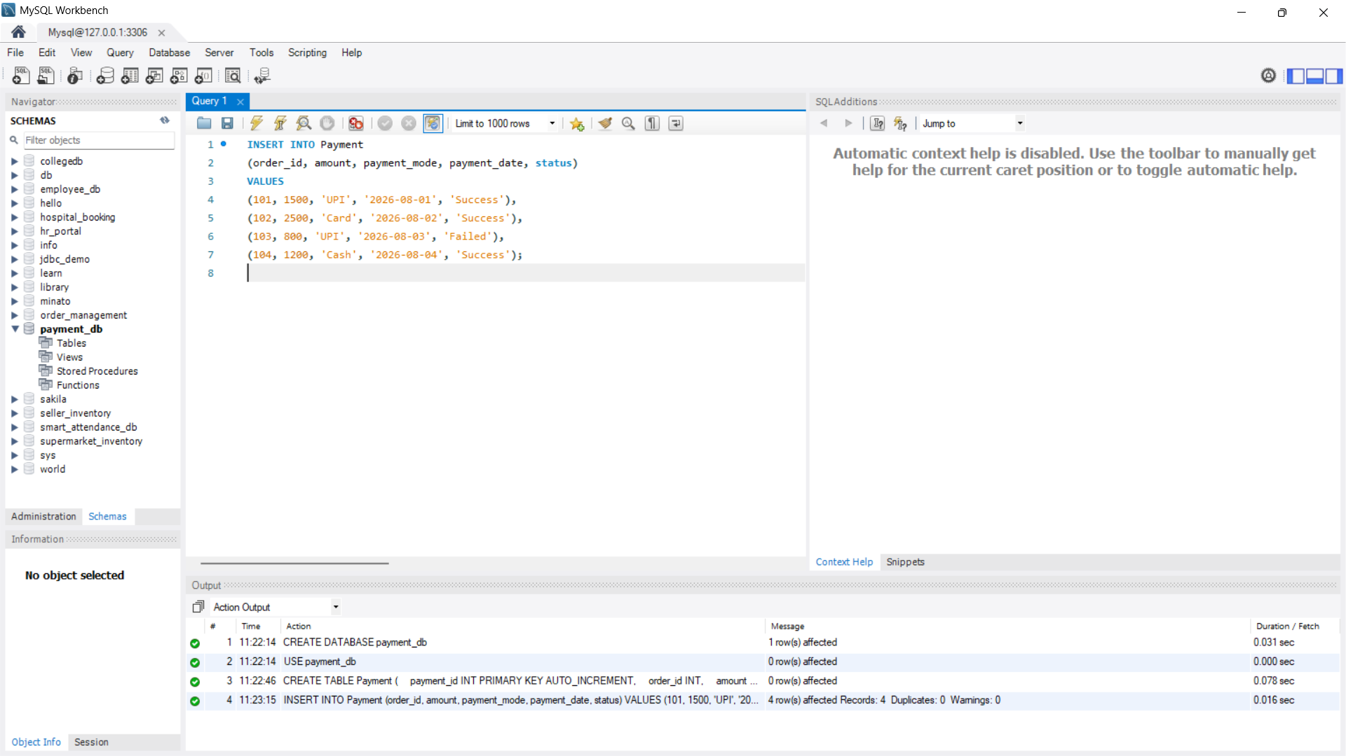
4. View All Payments
SELECT * FROM Payment;
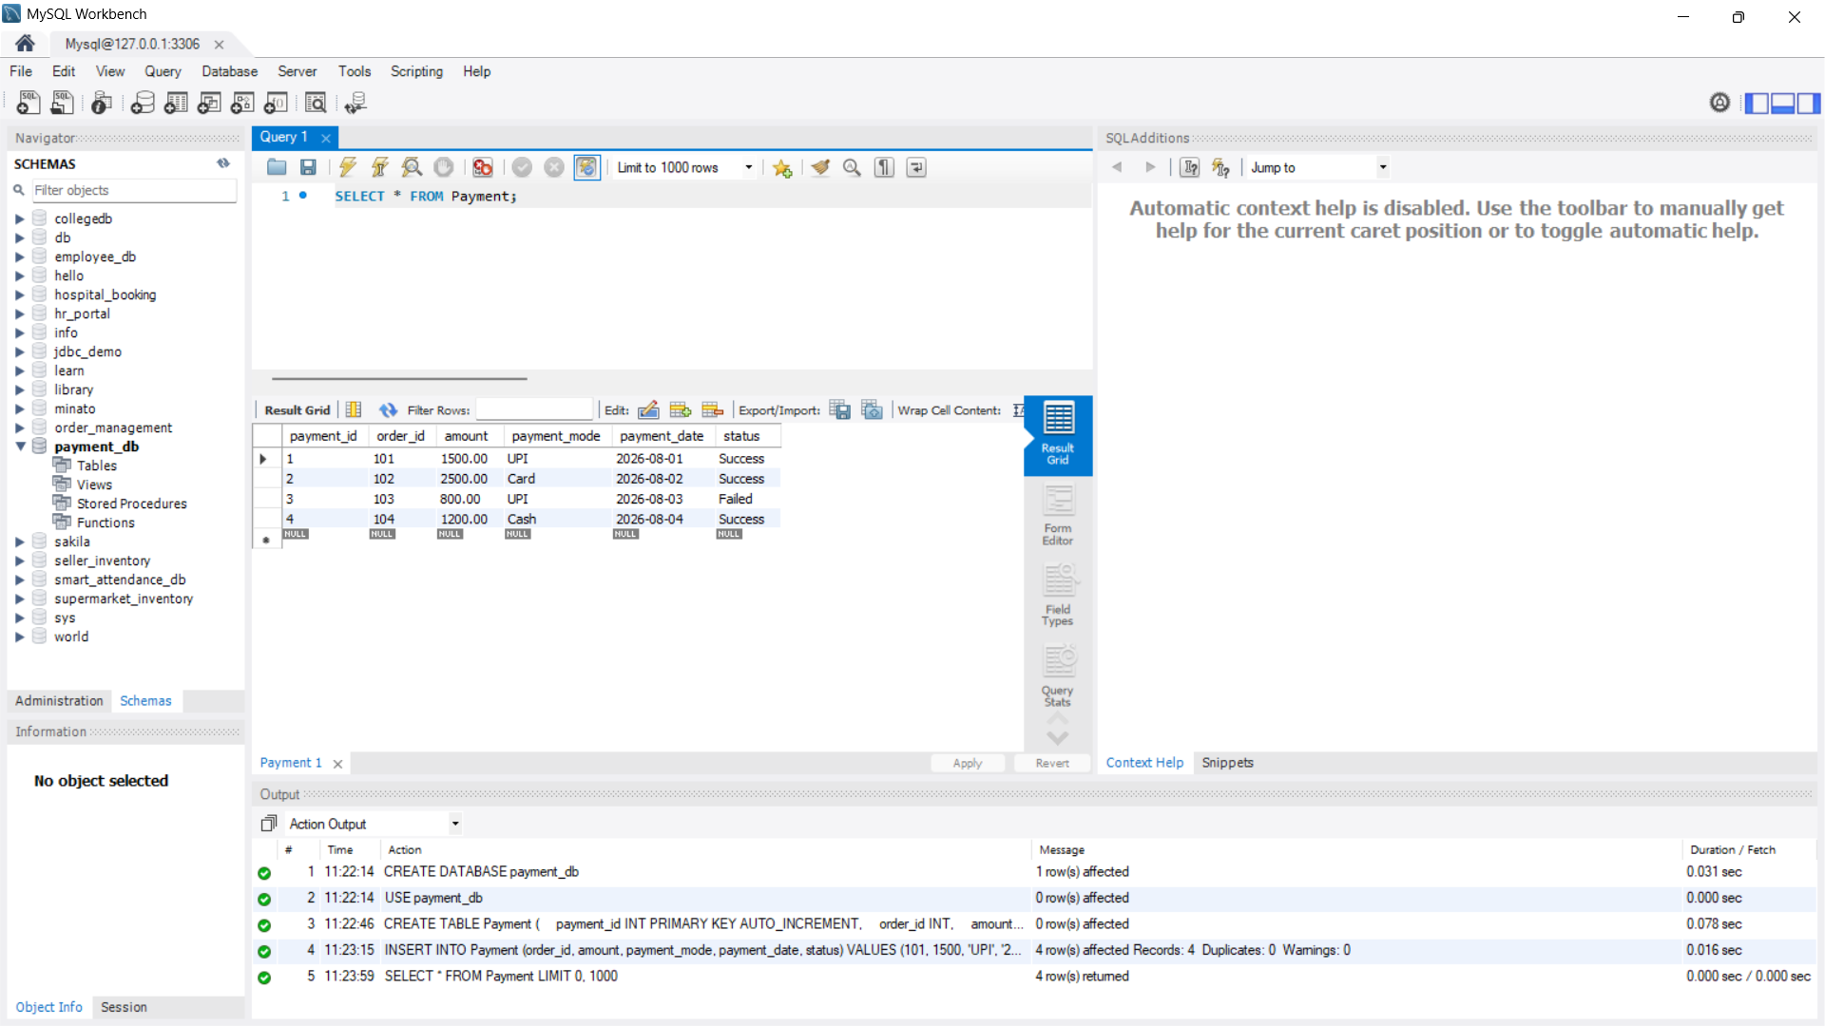
5. Successful Payments
SELECT * FROM Payment
WHERE status = 'Success';
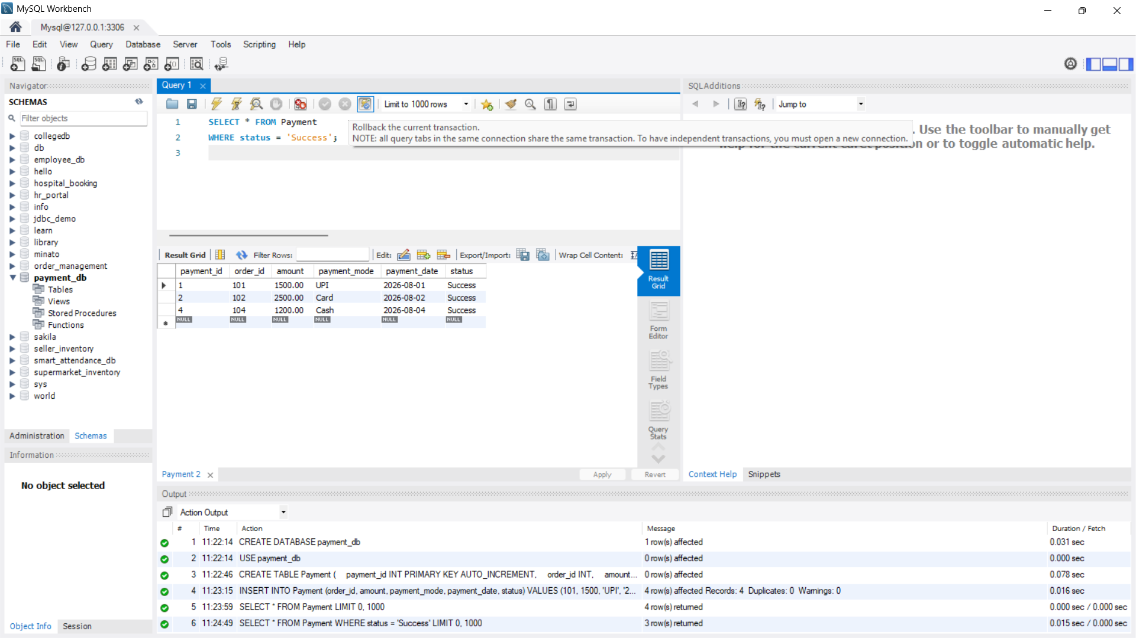
6. Failed Payments
SELECT * FROM Payment
WHERE status = 'Failed';
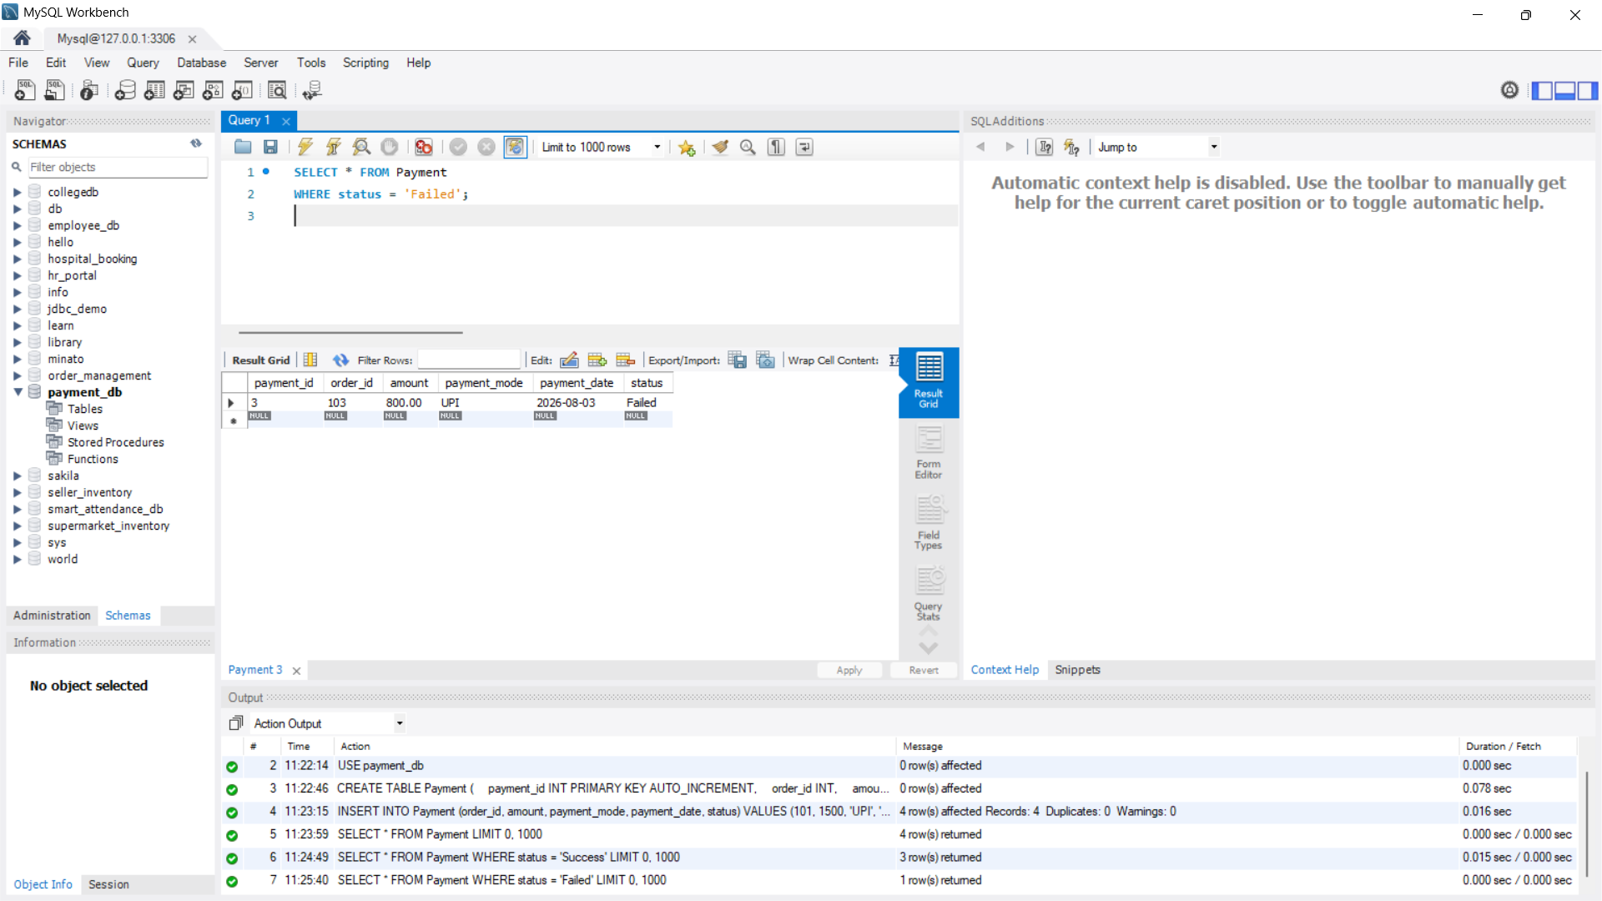
7. Analyze Payment Methods
SELECT payment_mode, COUNT(*) AS total
FROM Payment
GROUP BY payment_mode;
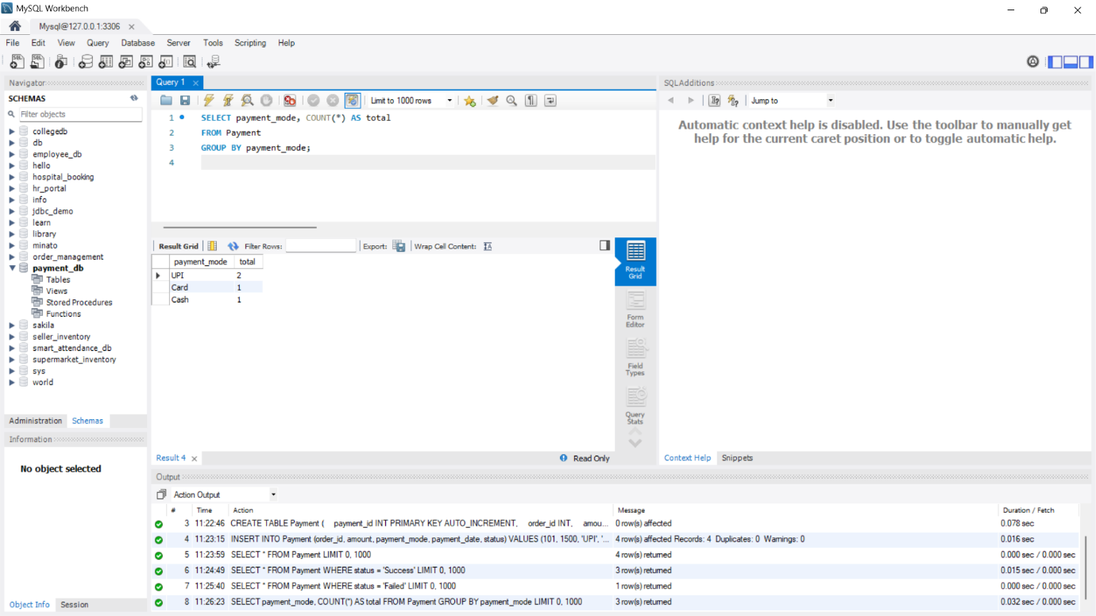

8. Total Payment
SELECT SUM(amount) AS total_amount
FROM Payment;
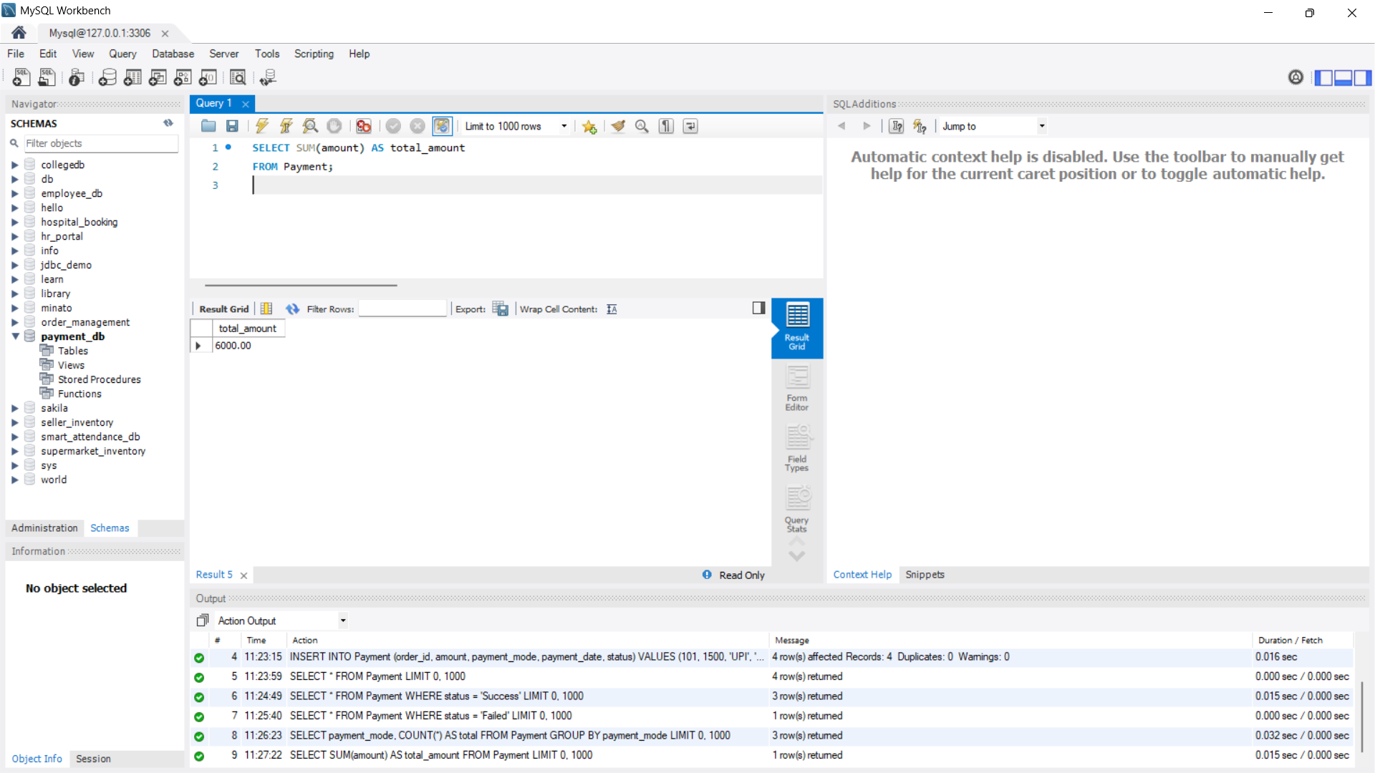

9. Payment Report
SELECT status, COUNT(*) AS transactions,
SUM(amount) AS total_amount
FROM Payment
GROUP BY status;
